Darknet---classification

1. 准备训练和验证数据

data/

train/

mud/

xxx.jpg

none/

xxx.jpg

test/

mud/

xxx.jpg

none/

xxx.jpg

2. 生成训练和测试文件

find `pwd`/train -name \*.jpg > train.list

find `pwd`/test -name \*.jpg > test.list

3. 定义分类标签labels.txt

none

mud

4. 修改data配置文件

class=2

train=/data/train.list

valid=/data/test.list

labels=/data/labels.txt

backup=/model

top=2

5. 修改cfg配置文件

[convolutional]

filters=2 //自己的类别数

size=1

stride=1

pad=0

activation=linear

[cost]

type=sse

6. 训练，测试，预测，验证命令

train:

./darknet classifier train CMS_Classifier/classifier/classify.data CMS_Classifier/classifier/darknet19.cfg > CMS_Classifier/classifier/log.txt

predict:

./darknet classifier predict CMS_Classifier/classifier/classify.data CMS_Classifier/classifier/darknet19.cfg CMS_Classifier/classifier/model/darknet19_3543.weights CMS_Classifier/classifier/data/test/none/00104.jpg

valid:

./darknet classifier valid CMS_Classifier/classifier/classify.data CMS_Classifier/classifier/darknet19.cfg CMS_Classifier/classifier/model/darknet19_3543.weights

分类任务评估结果：

top 1: 0.979167, top 2: 1.000000

-----------------------------------------------------------------

Opencv安装命令

sudo apt-get installbuild-essential

sudo apt-get install cmake git libgtk2.0-dev pkg-config libavcodec-dev libavformat-dev libswscale-dev

sudo apt-get install python-dev python-numpy libtbb2 libtbb-dev libjpeg-dev libpng-dev libtiff-dev libjasper-dev libdc1394-22-dev

cd opencv

mkdir build

cd build

cmake -D CMAKE_BUILD_TYPE=Release -D CMAKE_INSTALL_PREFIX=/usr/local -D WITH_GTK=ON -D WITH_GTK_2_X=ON ..

-D OPENCV_EXTRA_MODULES_PATH=../opencv_contrib/modules ..

//后面“../opencv_contrib-3.4.0/modules”为你opencv_contrib的modules文件夹所在的路径

sudo make -j8

sudo make install -j8

添加路径

sudo vim /etc/ld.so.conf.d/opencv.conf

sudo gedit /etc/ld.so.conf.d/opencv.conf

打开文件中添加如下内容：

/usr/local/lib

sudo ldconfig

sudo vim /etc/bash.bashrc

PKG_CONFIG_PATH=$PKG_CONFIG_PATH:/usr/local/lib/pkgconfig

export PKG_CONFIG_PATH

source /etc/bash.bashrc

至此，opencv及opencv_contrib安装配置完成了！sudo ldconfig

检查opencv安装成功的命令: pkg-config opencv --modversion

Darknet VS Opencv 3.4.14

1. Makefile

OPENCV=1

2. make error:

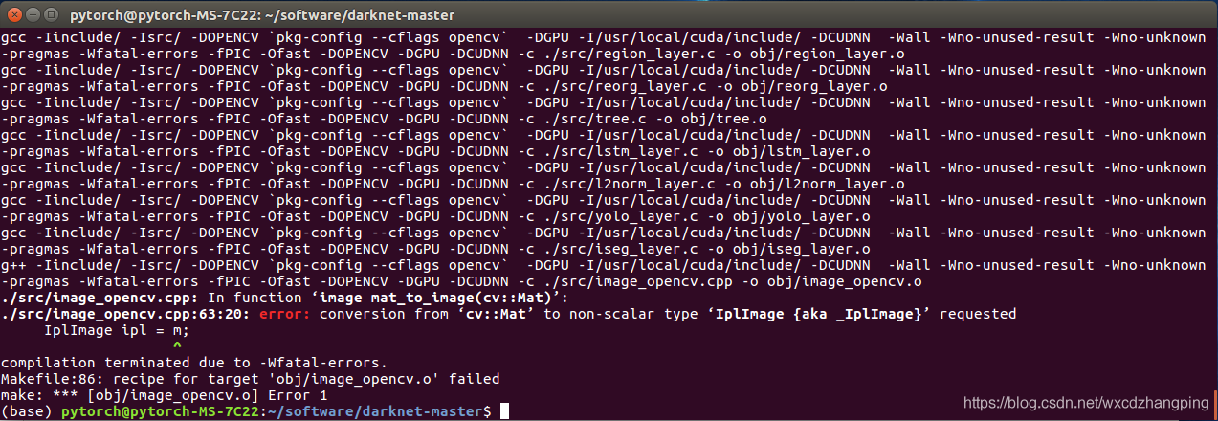

定位到源码的位置 是 image_opencv.cpp，如下：

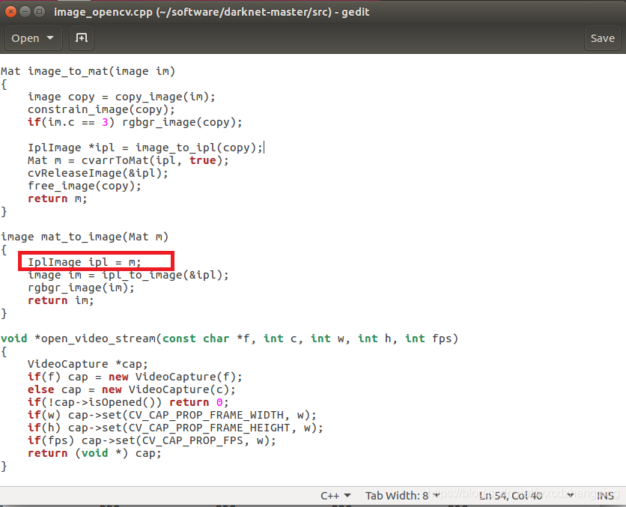

修改源码如下，即可：

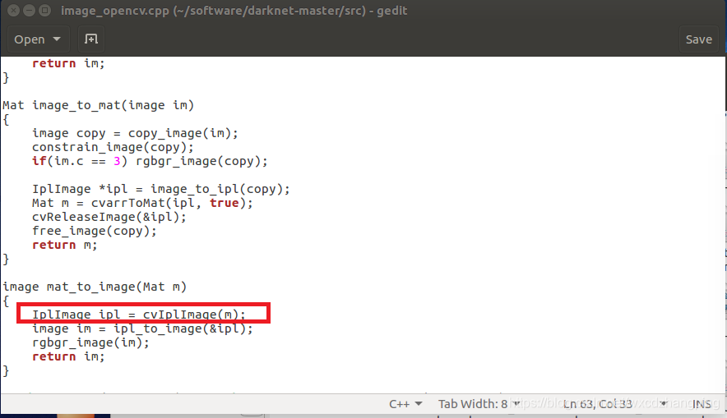编译通过!

3. terminate called after throwing an instance of 'cv::Exception'

what(): OpenCV(3.4.14) /home/ubuntu/tools/opencv-3.4.14/modules/highgui/src/window.cpp:641: error: (-2:Unspecified error) The function is not implemented. Rebuild the library with Windows, GTK+ 2.x or Carbon support. If you are on Ubuntu or Debian, install libgtk2.0-dev and pkg-config, then re-run cmake or configure script in function 'cvNamedWindow'

remake:

cmake -D CMAKE_BUILD_TYPE=Release -D CMAKE_INSTALL_PREFIX=/usr/local -D WITH_GTK=ON -D WITH_GTK_2_X=ON ..

make -j8

make install -j8

darknet:

make clean

make

https://blog.csdn.net/avideointerfaces/article/details/91958986